

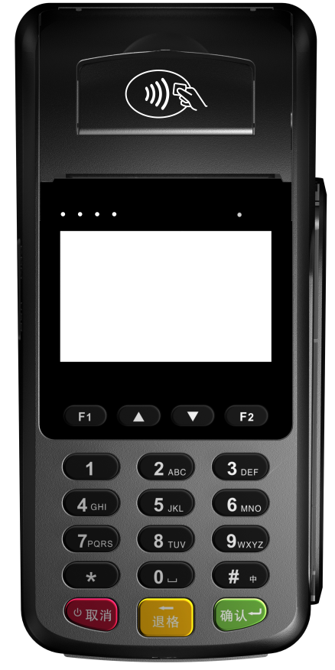

Morefun Wireless Hand-held MF90 POS Terminal User Manual
Read The Manual Before Using

Packing list
Please check whether complete components including :
(1)H9 POS Machine 1 Piece
(2)Power Adapter 1 Piece
(3)Lithium Battery 1 Piece
(4)User’s Manual 1 Piece
(5)Thermal Paper 1 Roll

Attentions

Safe Attentions：
◇This machine can only work with the specified power adapter . Do not replace it with other power sources , otherwise it may cause the machine to work improperly and even damaged !
◇Attentions of using battery:
*This machine can only work with the specified battery. Do not use any other type of battery.
*Do not disassemble, extrude, puncture or short-circuit battery;
*Do not place battery in fire or in water;
*Do not place it in the high temperature environment above 60℃ ,only in 20-60℃ temperature storage.
*The battery can only be charged using MF90 machine or a specified charging device.
*Contacts away from metal and other conductive objects to prevent contact short circuit；
*Seeking vendor support to replace the battery correctly;Do not discard carelessly the battery when it reaches its service life .Must be properly handled according to your local environment protecting requirements.
◇Do not clean the unit with alcohol or other corrosive liquids.

2. Password input anti-peeping attention：
◇The machine can only be used in a safe and secure environment；
◇When entering the password, use hand and body to block the perspective that may be peeped；
◇Do not enter the password in the environment where may be photographed the keypad area by camera；
3. Statement:
Any changes or updates to this device we reserve the right to change the documents at any time without notice .
Do not disassemble the equipment by yourself or we will not responsible for the warranty and replacement of the equipment.
Fujian Morefun Electronic Technology Co., Ltd own the trademark right and legal protection on the trademarks covered in this manual.

Product appearance
1. Paper cover handle ,NFC Induction Zone
2. Paper cover
3. Indicator light
4. Display screen
5. Card slot
6. Keypad Area
7. IC card interface
8. COM Interface
9. Micro USB Interface
10. SIM card Cover
11. Battery cover

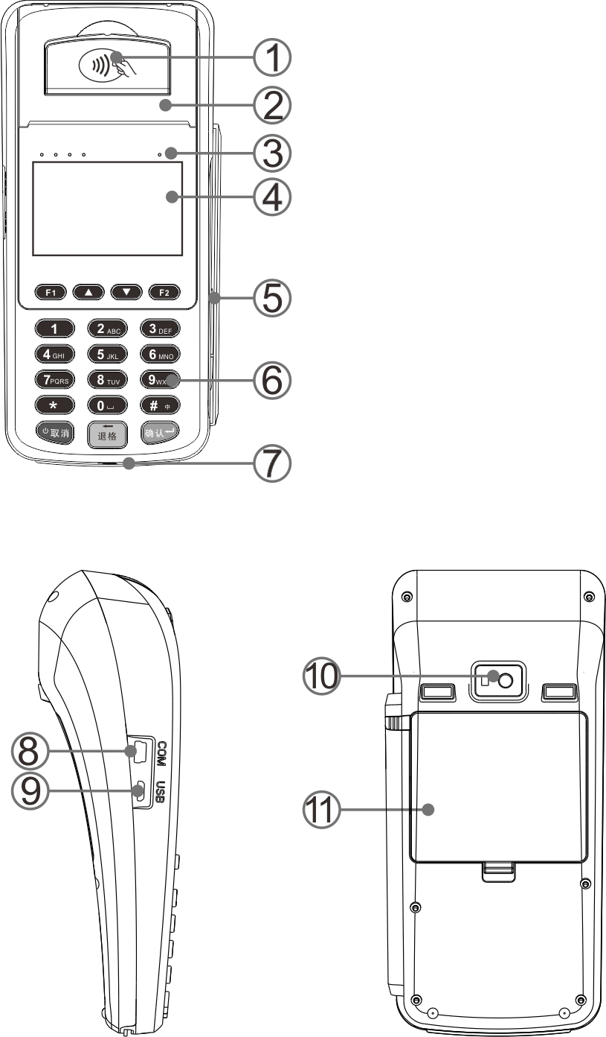

Battery installation and charging
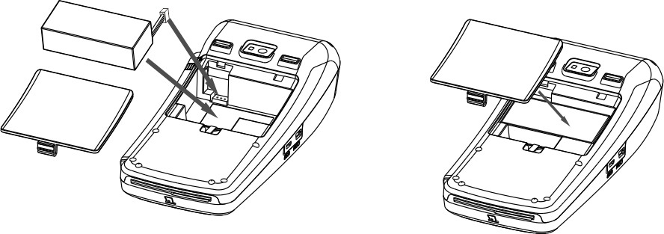

Install and replace the battery
1. The product must be used after the battery is installed；
2. Use the original battery of Fujian Morefun Electronic Technology Co., Ltd.；
3. Be sure to follow the installation diagram and incorrectly operation may cause battery damaged；

Battery Charging：
1. Confirmed that the battery has been already assembled；
2. Plug the power adapter with USB cable into the device power charging interface (USB ),the power adapter AC plug into 220V municipal power socket；
3. If the lithium battery power is not full ,the power indicator shows red；When it’s full ,the light will turn to green. At this moment can go on working with power adapter or using battery without power adapter.
Explanation：If it is boot charging, the charging state can be judged by the battery icon on the display screen. It’s full charging when it shows full grid icon. But if it shows lightning icon ,it’s still charging.

\

Installation SIM and SAM Card

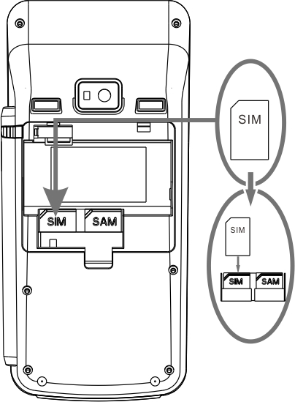
1. Remove the battery cover and lithium battery ；
2. Come out SAM and SIM cassette (as the picture shows )；
3. Take SIM card as an example, turn the SIM card contact chip toward the battery compartments , push into the SIM cassette from top to bottom and must be inserted into the bottom to ensure good contact;
4. The same installation of SAM card as SIM card，located on the right of SIM cassette；
5. Replace the lithium battery and install battery cover；
Attention！
◇Must be power off when install or remove SAM or SIM card , otherwise may cause card damaged；
◇Do not stick adhesive sticker on SAM or SIM. Label and other medium affect the card thickness, otherwise may cause install or remove SIM/SAM not smoothly；
◇SAM card slot is not standard part.

Install printing paper
1. Open the printer cover；
2. Place the paper and set aside a few centimeters of paper on the outside according to the correct hint in the print compartments；
3. Put down the cover to make sure the left and right alignment and do not shake; Push in fastening as shown；
4. Lightly pull the paper to confirm that the paper is solid, remove the extra printing paper with the cutting paper blade；
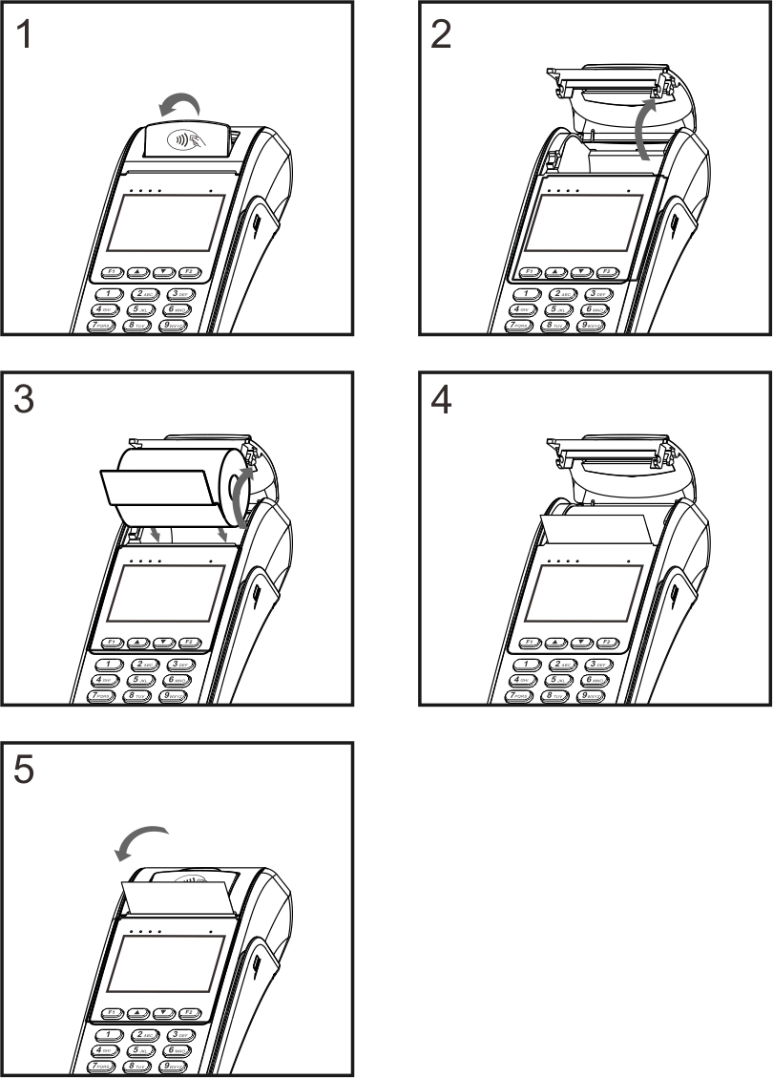
Attention：When the thermal paper is loaded, a heat-sensitive medium surface (the outer surface of the paper roll) need to face toward the printer’s heating head or the characters can not be printed correctly !

Teller operation on IC card、magnetic card and RF card
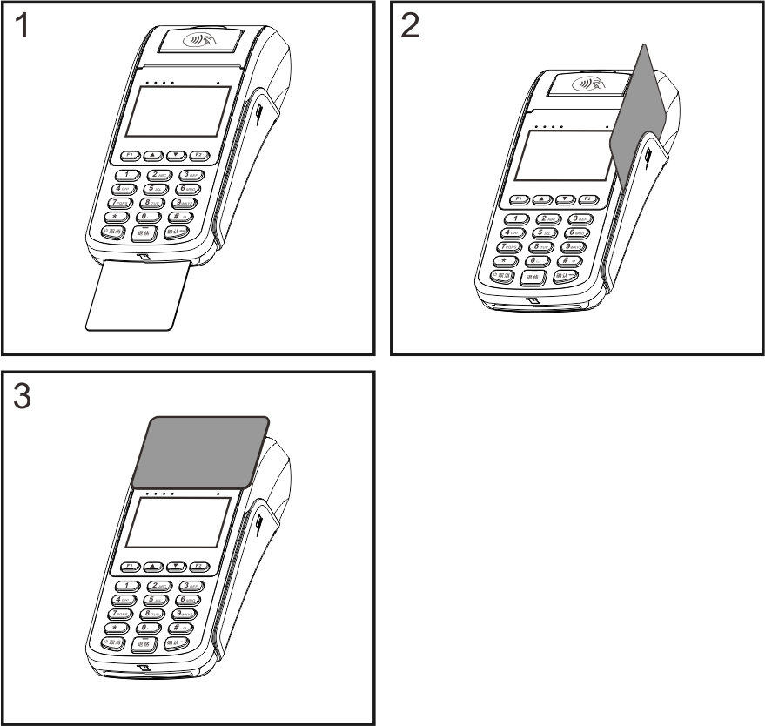

1. Inserting IC card into POS with contact surface chip up and the direction of the IC card arrow .
2. Swiping the card in the magnetic track with magnetic surface towards left and the display screen; when swiping the card, the card should be tightly inserted into the POS by sticking card slot and keep the constant speed as possible. You can swip the card from the top down or from bottom to top .
3.If RF card trading operation , please put on the reading area liket this picture “”.

Startup & Shutdown
Startup：Press and hold the power key when it’s off state “”. Will successful startup if show the boot screen after about 2 seconds then release the power button；
Shutdown：Press and hold the power key more than 2 seconds when it’s on state . “” Will shows the shutdown prompt interface please release the power button then select to confirm the shutdown.

Attention：
1. If encounter crashes please turn off the power and battery shutdown or press and hold the power button for more than 10 seconds to be off .
2. Please make sure that important transaction operations have been completed before the shutdown to avoid data loss.

Morefun Product Warranty Certificate
Thank you for purchasing Morefun products. In order to have a better using this product ,we offer a professional ,efficient and sincere service according to the following service commitments. And please be sure to ask the sales unit to fill in and stamp as required to protect your rights.
With this warranty certificate you will obtain our customer service and designated authorized service .

Morefun Product warranty service
Within 7 days of non-human damage performance failure, the customer can choose to repair or replace the same type of the products with valid purchase invoice and warranty certificate from the date of purchase. (Ensure the original host and all accessories complete )
During the warranty period, there are non-human damage performance failure that will be free maintenance with effective purchase invoice and warranty card in our designated customer service center or authorized maintenance center ;
Since the date of purchase ,the host warranty for one year.
Since the date of purchase, the battery warranty for 6 months, the charger including charging seat warranty for one year and external antenna warranty for one year.
After the warranty expires or does not belong to the scope of free warranty ,our company will provide paid maintenance services.
Any of the following conditions do not belong to the scope of free warranty during the warranty period：
◇Damage caused by flooding or man-made factors；
◇Failure to follow the instruction to use the damage caused ；
◇Damage caused by self-disassembly and maintenance；
◇Damage caused by external factors such as natural causes;
◇Failed to provide effective purchase invoice or valid warranty certificate, or did not fill in the required documents.

Product warranty card

（This page is the basic certificate of the warranty. Will be effective after the sales unit is sealed. Please fill out and keep it carefully）
Name/Address
Contact number
Model
Serial number
  Barcode same as host
adapter
others
Invoice number
Sales unit name
（with stamp）
Unit address
Responsible person
Purchase date

The
User
save

Fujian Morefun Electronic Technology Co., Ltd.
ADD：Fuzhou Gaoxin Area Haixi Gaoxin Industry Park Floor#10 Room A-602
Tel：0591-23507080
Web：www.morefun-et.com

